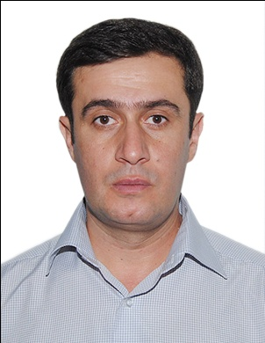
Name: Gaga Buishvili

Address: Telavi district, village Kv. Khodasheni

Mobile Phone: + 995 599376999

E- mail: Gagabuishvili2014@gmail.com

Date of birth: 07,09,1978 year.

Place of Birth: Telavi, Georgia

Marital status: married

Education/Qualification:

1995-1999 y.y. - State Agrarian University of Georgia, the wine technologist, Food Products Technology - Bachelor Degree (# 004063 Diploma with honors)
1999-2001 y.y. - State Agrarian University of Georgia, the wine technologist, Food Products Technology, Master Degree (Diploma # 001464)

2003-2008 y.y. - Gardener-Viticulture and Wine Scientific Research Institute, the wine

technologist, Alcoholic and non-alcoholic beverages technology - Doctor. (Diploma # 000063

Trainings, Conferences and certificates:

1. Flower pollen impact on the intensity of multiply the pure yeast culture ,, Kardanakh -42’’
M. Khositashvili, A. Asashvili, T. Khostiashvili, T. Kortava, G. Buishvili
International Scientific-Practical Conference Works
,, Innovative technologies and modern materials "Kutaisi 2010
2. PHENOLSINWINEANDTHEIRIMPORTANCEDakishviliG.T., Javakhishvili M.L.,andBuishviliG.TGEORGIANENGINEERINGNEWS 1’11
3. During the alcoholic fermentation the dynamics of changes the terpenes in the muscat grape Rkatsiteli and sweet
T. G. Qituashvili, M. L.Khostiashvili, G. T. Buishvili, T. V. Khostiashvili
GEORGIAN ENGINEERING NEWS 2’14
4. Agricultural - technological characterization of the vine varieties of muscat Rkatsiteli and Aleksandrouli muscat
T. G. Qituashvili, M.L. Khositashvili, G. T. Buishvili, T. V. Khositashvili
GEORGIAN ENGINEERING NEWS 2’14
5. Studying of the technological characteristics about white introduced varieties of grapes in Kartli
Mariam Khositashvili, Aniko Asashvili, Marina Kobakhidze, Gaga Buishvili.
International scientific-practical conference
Tourism: Economics and Business Batumi-Khikhani Valley 2014
6. Aromatic substances research of sweet and wine of muscat Rkatsiteli and Aleksandrouli muscat grape
T. Kituashvili, M.khositashvili, A. Asashvili, G.Buishvili
Academy News of Agricultural Sciences of Georgia
Tbilisi, August of 2014 year
7. The quality control of wine - Guidance, Telavi 2014.
Natalia Matiashvili, Shota Matiashvili, reviewer - Gaga Buishvili
8. Agricultural – technological studying of vine varieties of Kikhvi grape in order to obtain different types of wine. Monograph, Tbilisi, 2014 year. G. Buishvili, T. Glonti

Employment to date:
2003-2004 y.y. Wine Company,, Shumi "- Assistant Worker
2009-2014 y.y. Ltd. ,,ENKA House’’ – Director
2009-2012 y.y. Telavi State University of Iakob Gogebashvili, the invited Professor
From 2014 year - Associate Professor of Agricultural Sciences Faculty

Languages: Russian (good )
English (with dictionary)

Skills: Microsoft office word, Microsoft office excel, Microsoft office PowerPoint.

